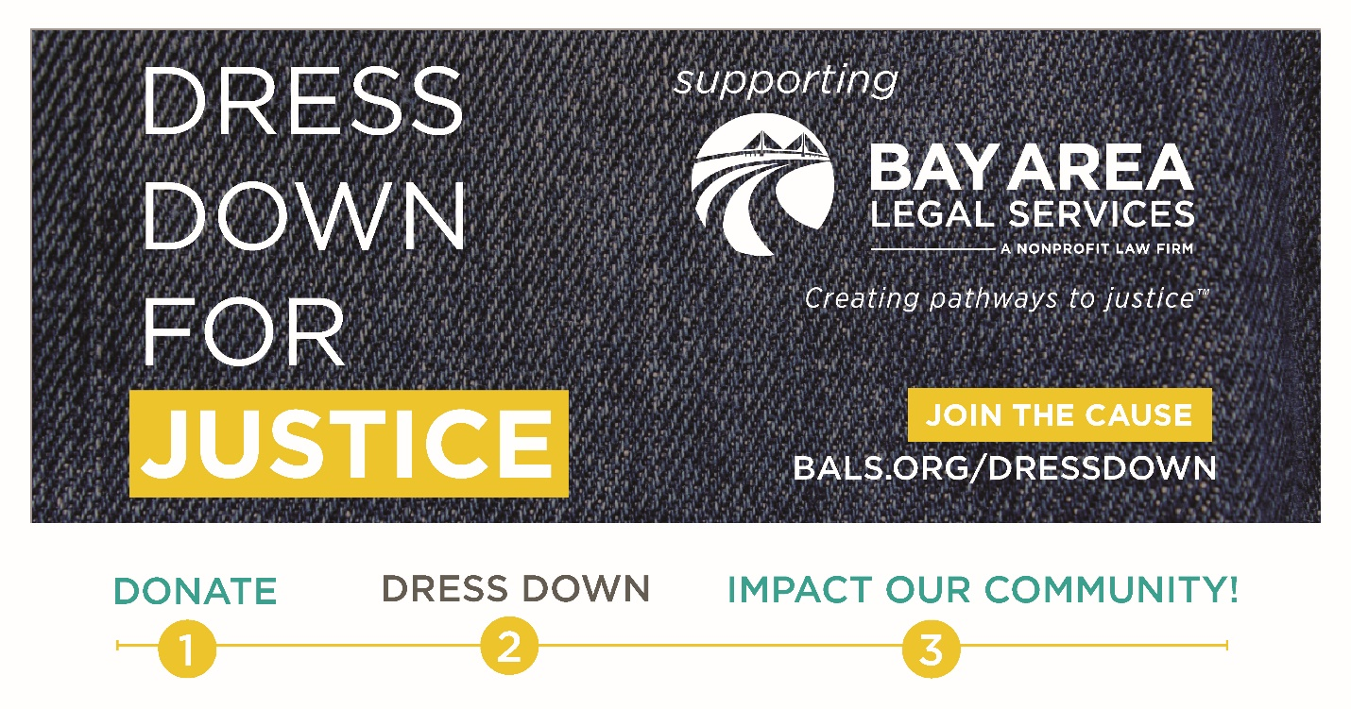
[NAME],
[WORKPLACE NAME] is proudly participating in Bay Area Legal Services’ Dress Down for Justice Drive. Through this important initiative, Bay Area Legal Services raises critical funds to ensure Tampa Bay residents have equal access to legal representation, regardless of their ability to afford it.
Legal aid helps root out the inequities that keep people in poverty and give a voice to low-income people during their greatest time of need.
Please join me in supporting [WORKPLACE NAME]’s Dress Down for Justice Campaign by donating a gift of any amount (I’ll be giving_____). We will participate in the campaign from [DATE – DATE] and hope to raise [$X,XXX]. Everyone who participates is invited to [fun description of capstone event or incentive] – don’t miss out!
Your Gift to Support Civil Legal Aid Helps:
- Domestic Violence Survivors obtain a divorce, custody, and injunction of protection.
- Struggling Veterans obtain housing and public benefits—avoiding homelessness.
- Senior Citizens who are being victimized
- Children in Foster Care obtain loving, stable homes
- And many other at-risk community groups have access to justice.
Please share your support for the Dress Down for Justice Drive on social media using the hashtag #DressDown4Justice and tag the account handle: @Bay_Area_Legal. To learn more about how Bay Area Legal Services creates pathways to justice click here.
Thank you for your support, and get ready to Dress Down in the name of justice!
Sincerely, [NAME]

